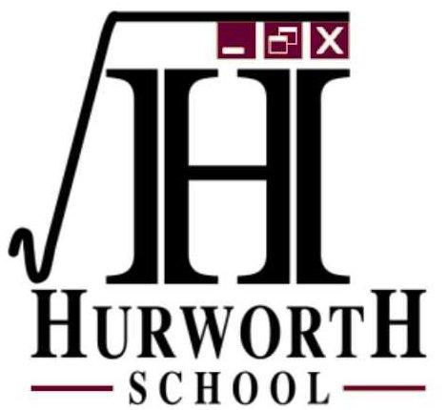
FAQ’s School Transport – Academic Year 2021-22

- How do I apply for a place on the school bus for my son or daughter?

On-line applications will be available from Monday 10th May 2021 to all parents of children at Hurworth in September 2021 that may require home to school transport, the on- line application form must be completed before 30th June 2021 to enable Hurworth School to deal with all applications.
http://www.hurworthschool.org.uk/transport-application/

- Will the school bus be ‘free’?

Darlington Borough Council has a duty to make the necessary travel arrangements for ‘eligible children’ under Section 508B of the Education Act 1996.
The Council will provide ‘free’ transport in the following circumstance
- To the nearest appropriate school which is more than 3 miles from the parental address
- To children entitled to free school meals or those families in receipt of the maximum working tax credit to:-
1 of their 3 nearest schools which is more than 2 miles but less than 6 and/or
To the nearest suitable school on grounds of religion or belief which is more than 2 miles but less than 15.

- If I don’t qualify for ‘free’ transport can I still apply for a place?
Hurworth School has agreed to offer a limited number of additional places on existing routes. The spaces are limited and there is no guarantee that every child that applies will be allocated a place.
- How much will the charge be?
Families will be charged £3.80 per day. If a family has more than one child that obtains a place on a bus, the eldest will be charged £3.80 then there will be a reduction of 10% (£3.42) for the first sibling.
- Will there be a reduction for sickness absence, holiday absence, exclusion etc?
No.
- What do I do if I no longer require the seat on the bus?
If a child no longer requires the seat on the coach the parent must inform Hurworth School of their decision and must return the pass to them in order that a refund can be calculated from the date of receipt of the pass itself.
Please turn over

- How can payment be made?

- Hurworth School will contact you to confirm that you have been successful in obtaining a fare-paying place. We offer parents a variety of ways to make payments, including standing order, cash, cheque and on-line via ParentMail. Passes will not be issued until payment has been received.
- Payment must be received termly in advance or by monthly standing order. If you would like to pay by monthly Standing Order the amounts are: £60.17/£54.15 per child/sibling for 12 months starting 1st August 2021. Payable to Hurworth School, Acc. 20986560 Sort Code 30-84-43. Please use your child’s name as the reference.

- If I am successful in gaining a fare paying place will this be in place for the duration of my child’s education?
We will attempt to enable your child to access transport for the full five years of their secondary education. However, this cannot be guaranteed as circumstances may change at any time.

