A
Survival Guide to
Transition

What is Transition?
Moving up from primary to secondary school is a major transition for students and their families. It is a period of change that can be both challenging and exciting. This year in particular, with all the schools being locked down due to the COVID -19 virus, it has been extremely difficult to get out and meet everyone as I usually would. Therefore, we are putting additional information onto our school website so that you can have a better understanding of what Hurworth School is all about. We hope this helps you in advance of your start in September.
At the moment we are unsure of how transition will happen in September but we will be in contact with you just as soon as we have a plan in place.

House system, forms and tutors
At Hurworth we have a House system which helps to promote healthy competition and a sense of family and pride. All students are placed into a form when they arrive and each form is in a House. E.g. 7C, 7R, 7S, 7T and 7W. Form tutors are selected each year and usually stay with their form all the way through to Year 11. The house names are:
COVERDALE
ROSEDALE
SWALEDALE
TEESDALE
WEARDALE
Each house has an associated colour which students wear on their school ties and sweaters. Points for good work, for taking part in extra-curricular activities, sports, reading, inter-house events and good citizenship etc. are awarded to the students and trophies are presented to the winning house each year.
Students usually stay in their designated house and tutor group all through school.

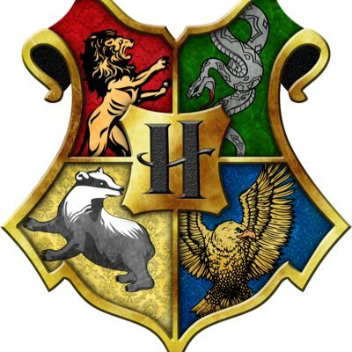

What set will you be in?
This year is a little different. We don’t have any SAT information about you and this is normally what we use to place you into the correct learning set. As we don’t have that information this year and because you have missed so much of your learning, we have decided to teach you in your form group until our teachers are able to carry out some assessments in their lessons. Hopefully, by the October half term we will have a better idea of which set you should be in and move you all accordingly.
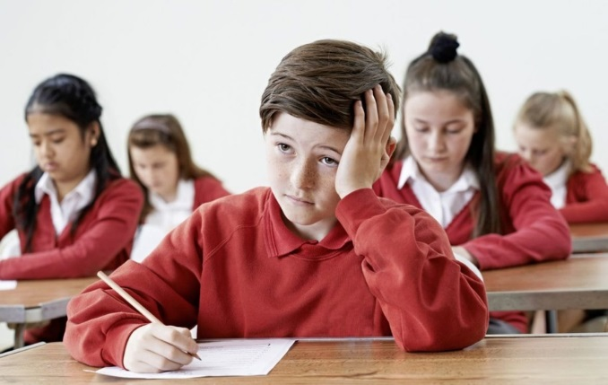

There are some students we already know about who will need additional support in all areas of school and these students will be placed in their learning group from the start and additional support provided as required. This will be arranged by the Special Educational Needs Department working with teachers in all subjects to ensure work is differentiated if necessary and resources placed in the correct areas to support those who need it most.
You will be assessed by teachers regularly in lessons to ensure you are making the appropriate amount of progress and receiving the right amount of support. Heads of Department meet regularly to ensure that students are still in the correct sets for their ability and on target. If they feel a move is necessary to help you achieve better results, this will be discussed with parents first.

Uniform
We are very proud of our students and expect them to wear the correct uniform and be proud of their appearance. All shoes should be proper black school shoes, not trainers – these are for PE only! They can be lace-up, buckle, slip on or Velcro fastening. No coloured soles, large bows or buckles or logos please.
Trousers should look like trousers, not tights, jeans or leggings – and should be black not grey.
We realise that during the lockdown it will be difficult for parents to purchase uniform and shoes, but if you can please do, so that our students have a good start.
Hair for girls should be one colour – no dip dyes or braiding. Boys should be no shorter than a number 2 anywhere on the head and should not have any designs or partings shaved into it or be coloured.
Make-up should not be worn and false nails are to be avoided at all costs as they can be very dangerous. Nails should be short and natural, not coloured.
Earrings should be very small studs in the ear lobe only and no necklaces or bracelets should be worn. A watch is fine although new smart watches need to be removed for exams.

The ‘dreaded’ Homework – or ILTs
Homework is always the thing that students worry most about when they come from Primary School as they hear so many horror stories about it. Our homeworks are called ‘Independent Learning Tasks’ or ILTs and are available to look at or print from the school’s website. They are marked and form part of a student’s overall grade in a subject. ILTs are divided into terms for different subjects so that students are not given too much each week. Students access ILTs through their Hurworth email address on Microsoft Teams. Please go to our Hurworth Website for more information.
WE EXPECT ILTs TO BE OF THE SAME QUALITY AS YOUR USUAL CLASSWORK
WE ALSO EXPECT THEM TO BE HANDED IN ON TIME

We know that some students struggle to complete ILTs and may need resources, computers, Internet etc. This is why we have a homework club on a Monday and Tuesday after school from 3.30pm – 4.30pm and why we have places in school where you can complete your ILTs at lunchtimes when staff are available to help you.
Please don’t try to tell us that the dog ate it!

Section 5
Friends and peer mentors
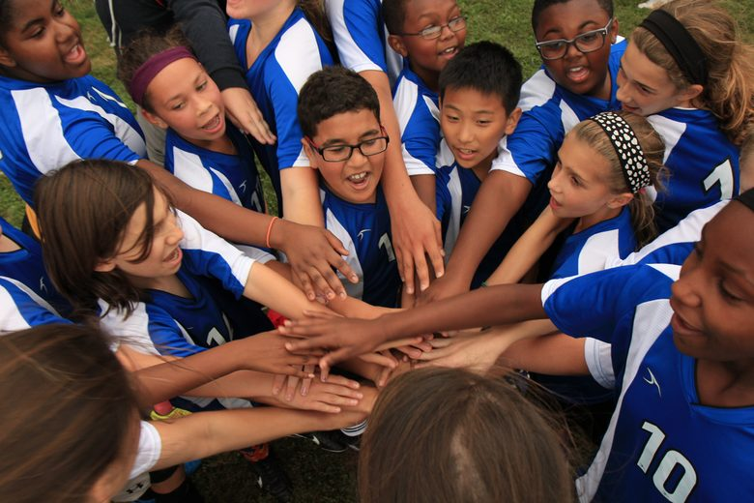
Where possible, we try to place you in a form with some of your friends from primary school. If you are the only person coming to Hurworth from your primary school, we will put you in a form with other students in the same situation so that you can make new friends.

Some of our lovely Year 8 students apply to become Peer Mentors and undertake a course in school so that they are prepared to help you during your transition days and when you start in September. They are there to help and guide you around your new school and in your new forms. If you’re unsure about asking an adult for help, then ask your peer mentors.
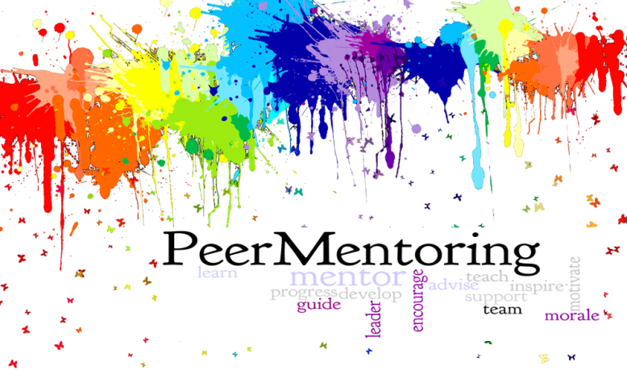

Rewards, rule breaking and sanctions
We have a system in school called Classcharts which awards:
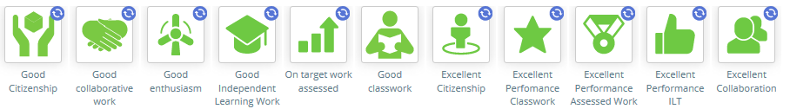
- green clicks for good work, attitude and behaviour
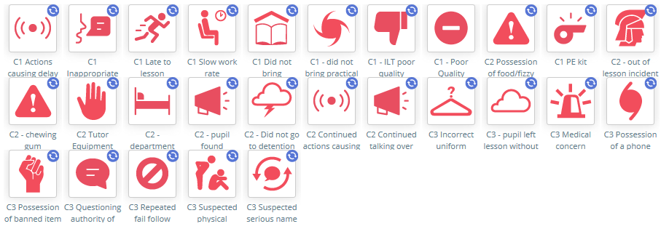
- or red clicks for work which is not up to standard, homework that has not been done or poor behaviour in class or around school.
- These form a kind of pie chart to show us how good your behaviour is. Your parents/carers can also see this at home!

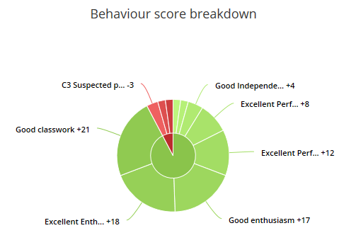

- Students who break the school rules will receive sanctions of; detentions, reports, internal exclusions and even external exclusions when necessary. Parents will be phoned by the Head of Year about any concerning behaviour or sanctions that are to be given. If students have a detention to attend, a text message will be sent to parents on the morning informing them.

- Mobile phones are not permitted in lessons. If you must bring one into school, it has to be signed in to the office staff on a morning before registration, and signed out again at 3.25pm. If you need to contact your parents during the day (to ask for a lift home, or about a sports club etc.) you can ask at the main office and use the phone there.
- There is no such thing as ‘Play Fighting’. In our experience this always leads to real fighting – DON’T DO IT!
- We do our best to investigate all incidents as fully as possible whether they be major or minor. Sanctions are often discussed by several members of the Pastoral Staff before a conclusion is arrived at and parents informed.

E-Safety and Social Media
Social Media has become an important part of most student’s lives. We have a number of lessons, assemblies etc. in school to discuss problems that can arise from students accessing Snapchat, Instagram etc. as things that happen on social media often end up coming into school. However, we are aware that technology changes every day and so we continually provide our staff and students with updates and new information as it becomes available.

Section 7

We try to support our parents and students so that they are able to use the Internet safely and have an awareness of the risks it can present by organising the following:
- Internet Safety Week where students complete a range of activities in registration time and in lessons.
- Assemblies on E-Safety twice a year for each year group.
- Resources and guides have been placed on the school’s website giving advice to students and parents.
- Pupils create their own ‘Code of Conduct’ around Internet safety.
- Computing lessons in school regularly talk about keeping safe and secure on the Internet and how to report any unwanted attention.
- There is an E-Safety and a Safeguarding Blog on the school website giving up to date information about new apps and the dangers they could pose to students.
- Any incident reported to school staff will be investigated and sometimes interventions from outside agencies are requested.

Food, glorious food
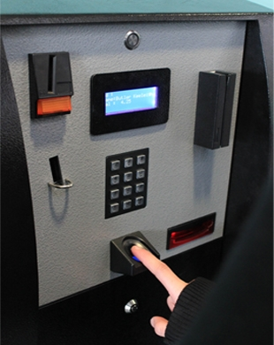
At Hurworth we operate a cashless catering system where you use your thumb print to access your account and charge food items to it. Parents can add funds to the account from home via the school’s website with a special account pin number provided by school. This enables them to check what has been bought each day and how much has been spent/how much is left. Money can also be paid into the machine in school.
Once we have the consent forms completed by parents we can arrange for students to either have their thumbprint taken or be given a 4-digit pin number to use. We usually try to have this completed during the two transition days at the end of June but this year we’ll be completing this task in September. Don’t worry, we never you let you go without your lunch!
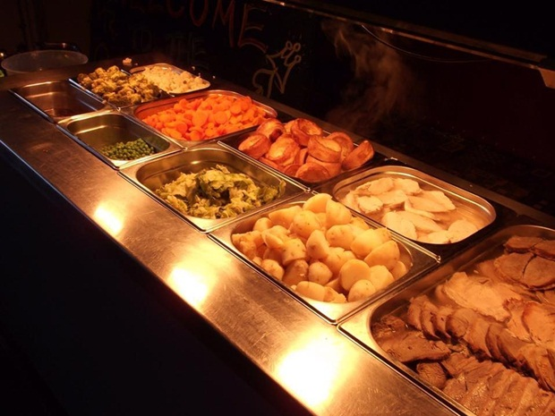
Our dining hall tries to cater to all tastes. Every day there is a hot meal deal option, pasta pots, jacket potatoes and fillings, several snack items, like pizza, Panini’s etc. and then we have a cold delicatessen bar which makes up sandwiches to order. There are also ready- made sandwiches and fruit, milk, juice drinks and free water.
We are open on a morning break where we sell bacon/egg buns, crumpets, toast and other brunch items. We do not sell crisps or fizzy drinks like coke.

What we provide for you
At Hurworth we try to provide all of our students with a great education. We are an ‘OUTSTANDING’ school and have excellent staff who want you to do really well and leave here with the best possible GCSE’s and life skills to take forward into your future lives.
We want you to take part in new subjects, fun activities and Inter-house events so that you learn new skills and meet new friends, which is why we organise lunchtime and after school activities, end of term activities, school visits in this country and abroad and trips to exciting places.
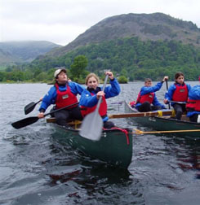
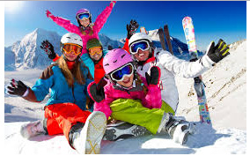

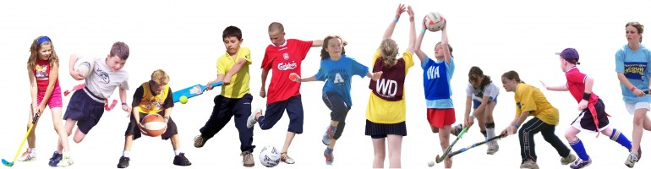

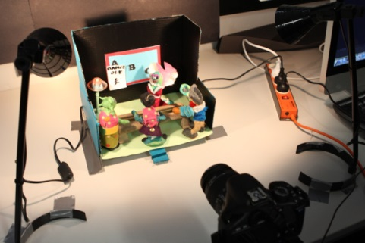
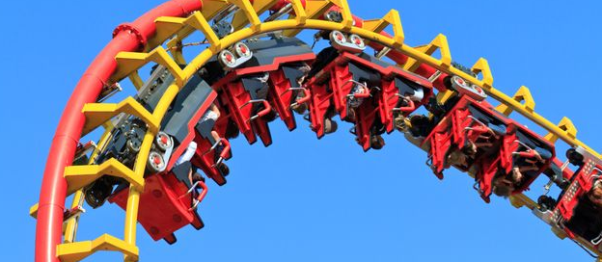
What we expect from you
Nobody is perfect, and most people struggle with some subjects at first, but we do expect every one of our students to try their best to be polite, respectful, well behaved and hard working. We will help you as much as possible along the way and we aim to make your time at Hurworth as happy as possible.

